InterNACHI® Pool & Spa Inspection Checklist

This basic inspection checklist is part of InterNACHI’s free, online “How to Inspect Pools and Spas” Course at www.nachi.org/pool-spa-course.
To have adequate and functional water flow through the pool system, there are several things that need to be in good shape:

- There has to be enough water in the pool or spa. Check the level of the water.
- There shouldn’t be any water leaks at the plumbing connections or equipment.
- All of the valves should be fully open.
- There shouldn’t be any trapped air in the system. Air at the filter tank should be purged routinely.
- The skimmer and main drain should be clear of blockages and debris. Skimmers require cleaning.
- The strainer pot at the pump should be cleaned routinely.
- There might be an imbalance of the water chemistry, causing scaling. Check for scale-causing clogging or restriction of water flow.
- The heater should be on and activated. The gas shut-off valve should be open. The switch should be on. Check for a pilot light, ignition, or flame at the fuel-fired heater. Check the level in the propane storage tank.
- The thermostat should be connected, active, and set properly.

The following inspection checklist was adapted from the guidelines recommended by the National Swimming Pool Foundation (NSPF). Use the checklist as a starting point in developing your own checklist that fits your inspection procedure and needs.
The inspector should check for the following:
- Adequate fencing, gates, barriers, alarms, and/or other protective devices are installed.
- Adequate storage space is provided for equipment.
- Decks around pool are not cluttered.
- The pool is covered when not in use.
- Surfaces leading to the pool, including the deck and steps, are slip-resistant.
- Decks on all sides of the pool meet minimum safety standards.
- The deck is separated from the pool wall perimeter.
- There are no standing puddles on the deck.
- 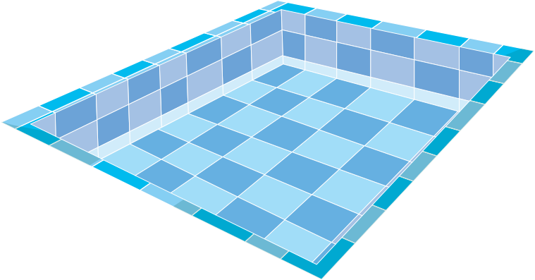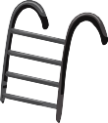All ladders, stanchions, chairs, and rails have treads with a contrasting color coating or tile on both the top and vertical rise.
- No unpleasant odors or irritating fumes are apparent.
- No physical damage is apparent at the pool equipment.
- Main drain grates are bolted securely to the pool’s bottom.
- Grates are visible from the deck, with no apparent damage.
- Drain covers are installed.
- Water return inlets are installed.

- The pool is vacuumed daily.
- No debris is visible. The water is clean.
- There’s no discoloration of the water.
- There is no visible algae growth.
- The pool water is tested at the frequency required or desired.
- All water quality and chemical levels were within acceptable ranges as of the most current test.
- Bacteriological water analysis is performed on a regular basis.
- The water temperature is maintained within acceptable levels and is appropriate for the primary activities being conducted in the pool.
- The water temperature has been measured and recorded.
- The type of heater is identified.
- The efficiency and BTU ratings of the heater are identified.
- The heater is installed on a level, non-combustible base.
- Safety devices are installed on the heater.
- The thermostat is located and identified.
- Check valves between the heater and filter are installed.
- Bonding and grounding are visible.
- The heater is installed downstream of the pump and filter.
- A solar-heating system is installed.
- The solar-heating system type is identified.
- The solar-heating system is active.
- Pool chemicals are stored a safe distance away from the heater.
- Adequate clearances around the heater are maintained.
- Coping stones and tiles are not chipped, cracked or loose.
- The pool shell appears smooth, without readily visible defects.
- There is no visible surface staining.
- The water level appears to be maintained to allow for the removal of floating debris.
- The water level appears at the proper height to allow continuous overflow of water into the gutters or skimmers.
- Skimmer weirs, skimmer baskets, deck covers, and flow-adjustment devices are installed.
- Lights are installed and are operational.
- The type, number and wattage of deck lighting are identified.
- The number of underwater lights is noted.
- GFCIs are installed.
- Electrical wiring is not passing directly over the pool or spa.
- Hose bibs are installed near the pool.
- 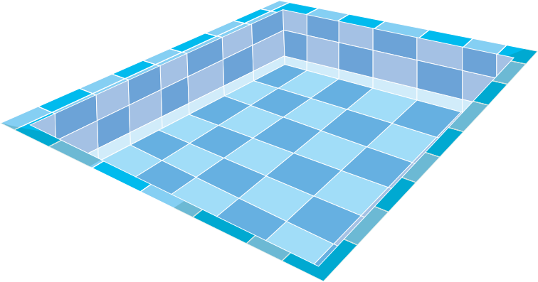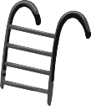No apparent defects or signs of repair are observed at the diving board.
- The manufacturer of the diving board is visible on the board itself.
- The centrifugal pump is secured to its base and is operating quietly.
- The hair and lint strainer basket is clean of debris.
- The type of pipe has been identified.
- Pipes and fittings are not leaking.

- Pipes are supported adequately.
- Pipes are not showing signs of calcification, corrosion or deterioration.
- Air pressure-relief valves are installed on all pressure filter tanks.
- Filter tanks are accessible.
- The filter’s brand is identified.
- A clean sight glass or visual outfall of at least 3 feet has been provided.
- The pressurized filter tanks and hair and lint traps are not leaking and are properly sealed.
- All piping, filters and components that are part of the system are labeled, tagged, color-coded, or otherwise identified.
- A spa is installed.
- The spa is operational.
- A spa cover is installed.
- No physical damage is apparent at the spa.
- A spa timer is installed and not reachable by a spa user.
- The emergency shut-off switch for the spa is installed and clearly labeled.
- The spa appears clean and adequately maintained.

